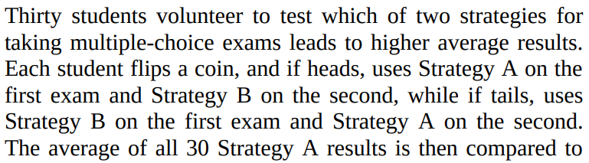**MCQ:**

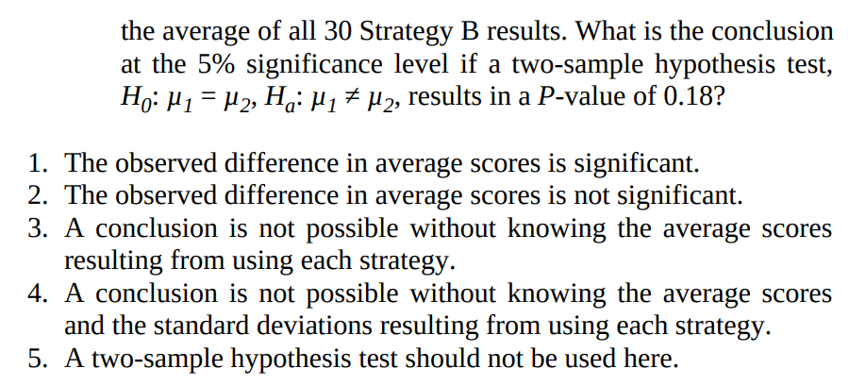

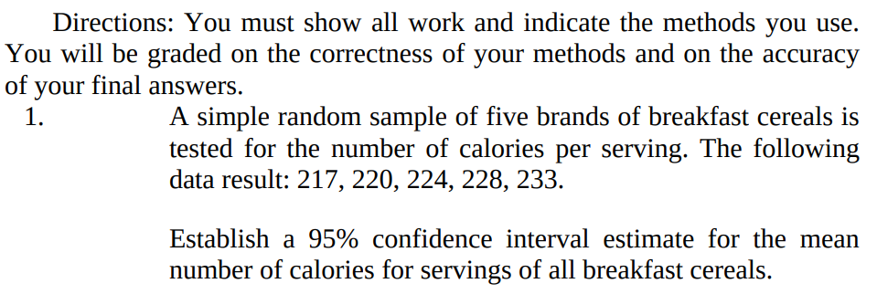**FRQ:**

2. To study the long-term effects of preschool programs for poor children, researchers designed an experiment. They recruited 123 children who had never attended preschool from low-income families in Michigan. Researchers randomly assigned 62 of the children to attend preschool (paid for by the study budget) and the other 61 to serve as a control group who would not go to preschool. One response variable of interest was the need for social services as adults. Over a 10-year period, 38 children in the preschool group and 49 in the control group have needed social services.

Do these data provide convincing evidence that preschool reduces the later need for social services for children like the ones in this study? Justify your answer.

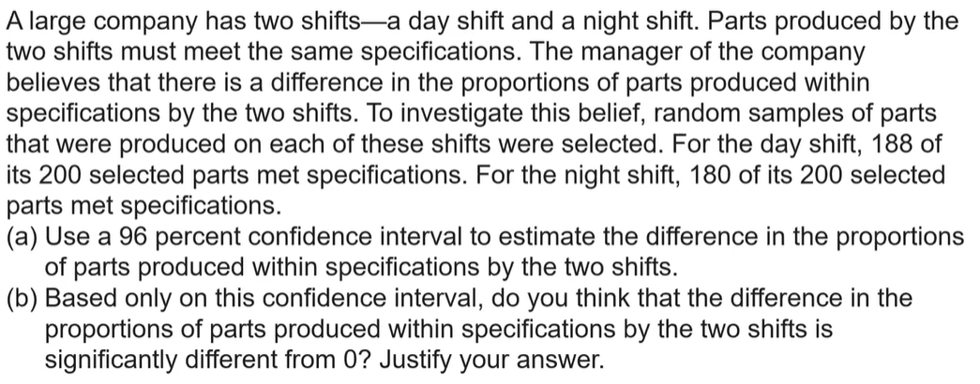

Answer Sheet:

|  |
| --- |
| MCQ: |
| FRQ.1. |
| FRQ.2. |